

Project Interim Report

On

Digital Stopwatch Logic Simulation

(Using Core Java & OOP Concepts)
RU-100-05-00018
Object Oriented Programming with Java

SESSION: 2025-26

Submitted By
Aditya singh
RU-25-10115
Bachelor of Computer Application
with AI and ML in association with Google

Under the Guidance of
Harsh Multani Sir

SCHOOL OF INFORMATION & TECHNOLOGY
RUNGTA INTERNATIONAL SKILLS UNIVERSITY
BHILAI, CG

(April 2026)

Table Of Content

Serial No. | Title | Page Number
 | Abstract | 3
 | Introduction | 4
 | Scope
 | System Requirements
 | Methodology
 | Flowchart
 | Implementation
 | Gantt Chart
 | Conclusions
 | References

ABSTRACT

The Global Currency Converter is a Java-based application developed using Object-Oriented Programming (OOP) concepts. The primary objective of this project is to convert different international currencies such as USD, EUR, and GBP into Indian Rupees (INR).

With globalization and the rise of international travel and online transactions, currency conversion has become an essential requirement. This system uses static variables to store exchange rates and static methods to perform conversions, eliminating the need for object instantiation and ensuring efficient memory usage. The application accepts user input for the amount and the currency type, processes the conversion, and displays the equivalent value in INR.

The project demonstrates key OOP principles such as encapsulation and utility class design. It is simple, efficient, and can be further enhanced by integrating real-time exchange rates and a graphical user interface.

INTRODUCTION

The Global Currency Converter is a Java-based application developed using Object-Oriented Programming (OOP) concepts to provide an efficient and reliable solution for converting international currencies such as USD, EUR, and GBP into Indian Rupees (INR). In today’s rapidly evolving world of globalization, international trade, and online transactions, the need for accurate and quick currency conversion has become increasingly important. This system simplifies the conversion process by allowing users to enter an amount and select a desired currency, after which the equivalent value in INR is calculated and displayed instantly. (Yeh project global level par alag-alag deshon ki currencies ko Indian Rupees mein convert karne ke liye banaya gaya hai.)

The project emphasizes the effective use of static variables to store predefined exchange rates and static methods to perform the conversion logic. This utility class design eliminates the need for object instantiation, ensuring efficient memory usage and centralized management of data. By encapsulating the conversion functionality within a single class, the system demonstrates the principle of encapsulation, which enhances code reusability, maintainability, and modularity. (Is project mein static members ka use karke exchange rates ko manage kiya gaya hai, jisse system simple aur efficient ban jata hai.)

Furthermore, the Global Currency Converter provides a user-friendly interface that minimizes manual calculation errors and delivers accurate results in a short period of time. The application serves as an excellent educational example for understanding real-world implementation of OOP principles in Java. It can also be extended in the future by integrating real-time exchange rate APIs, adding support for more currencies, and developing a Graphical User Interface (GUI) for enhanced usability. (Yeh system users ko sahi aur fast currency conversion provide karta hai aur future mein ise aur advanced banaya ja sakta hai.)

Key Features
- Conversion of multiple currencies (USD, EUR, GBP) to INR.
- Use of static variables for exchange rates.
- Static methods for conversion logic.
- User-friendly console interface.
- Error handling for invalid inputs.
- Efficient and reusable utility class design.

Objectives

1 To develop a currency conversion system using Java.

2 To demonstrate the use of static variables and methods.

3 To apply Object-Oriented Programming concepts.

4 To provide an easy-to-use interface for users.

5 To reduce manual calculation errors.

6 To design a reusable and efficient utility class.

SCOPE

The Global Currency Converter project is designed to provide a simple and efficient solution for converting major international currencies such as USD, EUR, and GBP into Indian Rupees (INR). The system is particularly useful for individuals involved in international travel, online shopping, and global financial transactions, where quick and accurate currency conversion is essential. By utilizing predefined exchange rates, the application ensures reliable results and serves as a practical tool for understanding real-world financial calculations. (Yeh project un logon ke liye upyogi hai jo foreign currencies ko INR mein jaldi aur sahi tareeke se convert karna chahte hain.)

From an academic perspective, the project demonstrates the effective implementation of Object-Oriented Programming (OOP) concepts, particularly the use of static variables, static methods, and utility class design. It provides students with a clear understanding of encapsulation, code reusability, and modularity, making it an excellent educational model for learning software development practices in Java. The application can be easily executed on standard computer systems without the need for complex configurations, thereby increasing its accessibility and usability.

The scope of this project can be further extended by integrating real-time exchange rate APIs to provide up-to-date conversion values. Additional enhancements may include support for multiple currencies, development of a Graphical User Interface (GUI) for improved user interaction, and transformation into a web or mobile-based application. These future improvements would enhance the scalability and practical applicability of the system in real-world scenarios.

SYSTEM REQUIREMENTS

The Global Currency Converter is designed to operate efficiently within a standard computing environment, requiring minimal hardware resources. The system can be executed on a computer or laptop equipped with at least 4 GB RAM, a dual-core processor, and essential input/output devices such as a keyboard, mouse, and monitor. These basic specifications ensure smooth performance, fast processing, and a user-friendly experience, making the application accessible to students and users without the need for high-end equipment.
From a software perspective, the application is developed using the Java Programming Language, which necessitates the installation of the Java Development Kit (JDK 8 or above) for successful compilation and execution. To enhance the development process, an Integrated Development Environment (IDE) such as Visual Studio Code, Eclipse, or IntelliJ IDEA is recommended, as these tools provide advanced features like code editing, debugging, and project management. The system is compatible with multiple operating systems, including Windows, Linux, and macOS, thereby ensuring platform independence and flexibility for a wide range of users

In addition to the basic requirements, the system benefits from a console-based user interface, which simplifies user interaction and minimizes system complexity. Although the current implementation utilizes predefined exchange rates, the architecture allows for future enhancements such as real-time exchange rate integration, database connectivity, and the development of a Graphical User Interface (GUI). These capabilities highlight the scalability and extensibility of the system, ensuring its relevance for both educational purposes and real-world applications.

Hardware

Computer/Laptop with at least 4 GB RAM

Keyboard and Monitor

Software

Java Development Kit (JDK 8 or above)

IDE: VS Code / Eclipse / IntelliJ IDEA

Operating System: Windows / Linux / macOS

METHODOLOGY

The development of the Global Currency Converter follows a systematic and structured approach to ensure accuracy, efficiency, and reliability in currency conversion. The process begins with requirement analysis, where the need for a simple and effective system to convert international currencies such as USD, EUR, and GBP into Indian Rupees (INR) is identified. This phase involves understanding user expectations, defining system objectives, and determining the scope of the application. The insights gained during this stage form the foundation for designing a robust and user-centric system.

Following the requirement analysis, the system design phase focuses on creating an efficient architecture based on Object-Oriented Programming (OOP) principles. A utility class, namely ConverterEngine, is designed to encapsulate the conversion logic. The system utilizes static variables to store predefined exchange rates and static methods to perform the conversion operations. This design ensures centralized management of data, efficient memory usage, and eliminates the need for object instantiation, thereby enhancing the overall performance and maintainability of the application.

The implementation phase involves developing the application using the Java Programming Language, where the designed classes and methods are translated into functional code. A console-based user interface is provided to facilitate user interaction, allowing users to input the desired amount and select the currency type. The system then processes the input by applying the corresponding exchange rate and generates the converted value in INR. Additionally, input validation and error handling mechanisms are incorporated to manage invalid currency selections and ensure the robustness of the system.

he final stage of the methodology includes testing, evaluation, and future enhancement planning. During the testing phase, the application is executed with various input scenarios to verify the correctness and reliability of the conversion logic. The evaluation ensures that the system meets its intended objectives and performs efficiently under standard operating conditions. Furthermore, the project is designed with scalability and extensibility in mind, allowing for future improvements such as real-time exchange rate integration, addition of multiple currencies, and the development of a Graphical User Interface (GUI).

The project follows a structured approach:

Requirement Analysis: Identify the need for a currency conversion system.

System Design: Create a utility class (ConverterEngine) to manage exchange rates and conversion logic.

Implementation: Define static variables for exchange rates and implement a static convert() method.

User Interaction: Accept input from the user via the console.

Processing: Apply the selected exchange rate to compute the converted value

Output: Display the converted amount in INR.

Testing: Validate the system with various inputs and handle invalid currency types

FLOWCHART

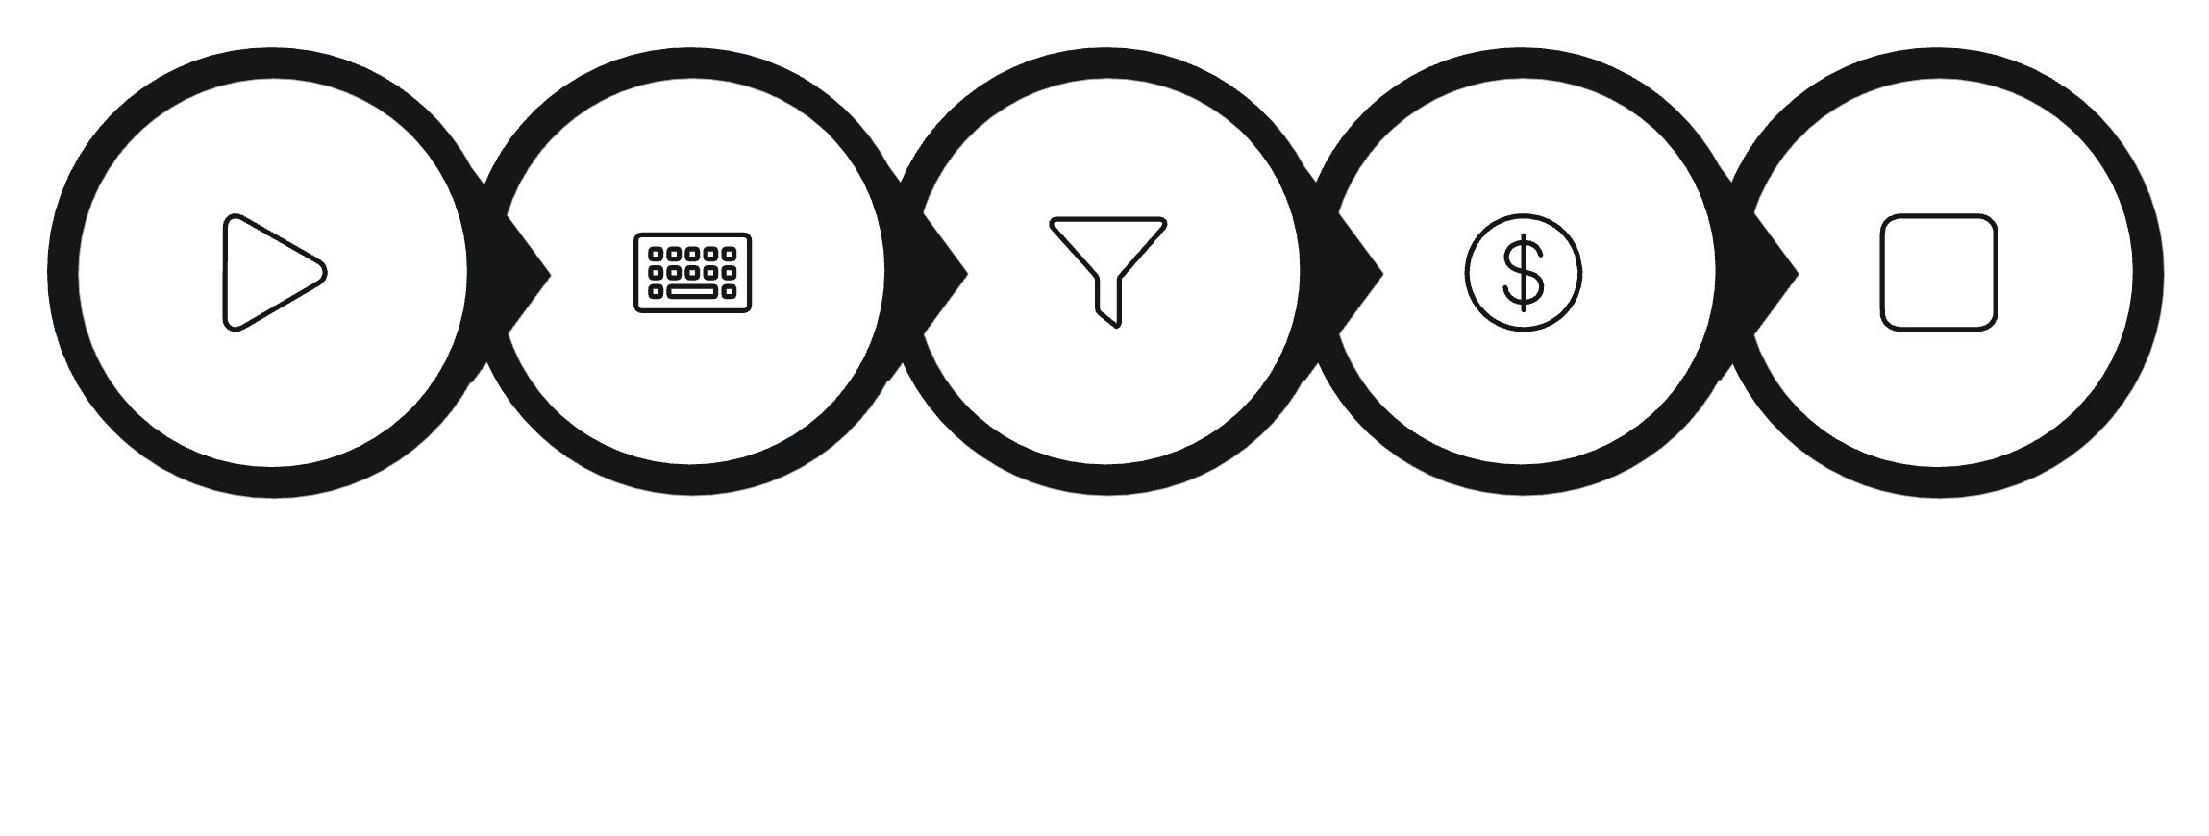

Start

|

v

Enter Amount and Currency Type

|

v

Check Currency Type

|

+---- USD ----> Convert using USD rate

+---- EUR ----> Convert using EUR rate

+---- GBP ----> Convert using GBP rate

|

v

Display Converted Amount

|

v

End

IMPLEMENTATION

*Overall System Implementation

The Implementation of the Global Currency Converter focuses on transforming the system design into a functional application using the Java Programming Language. The project follows the principles of Object-Oriented Programming (OOP) to ensure modularity, reusability, and maintainability. The system is structured into separate classes, each responsible for specific functionalities, enabling a clean and organized architecture. This structured approach enhances the readability and scalability of the application, making it suitable for both academic and practical purposes.

– ConverterEngine Class

A central component of the system is the Utility Class named ConverterEngine, which encapsulates the core conversion logic. This class utilizes Static Variables to store predefined Exchange Rates for major currencies such as USD, EUR, and GBP against Indian Rupees (INR). Additionally, Static Methods, particularly the convert() Method, are implemented to perform the currency conversion without requiring Object Instantiation. This design ensures Centralized Management of exchange rates and promotes Efficient Memory Usage, making the application lightweight and efficient.

– Main Class and User Interaction

The Main Class, typically named GlobalCurrencyConverter, is responsible for managing User Interaction and controlling the overall program flow. A Console-Based User Interface is implemented using the Scanner Class to accept user inputs such as the Amount and Currency Type. The entered data is then passed to the convert() Method of the ConverterEngine class, and the resulting Converted Amount is displayed to the user. This interaction ensures a User-Friendly Experience and demonstrates effective communication between different components of the system.

– Input Validation and Error Handling

To enhance the Reliability and Robustness of the application, appropriate Input Validation and Error Handling mechanisms are incorporated. The system verifies whether the entered Currency Type matches the supported currencies and handles invalid inputs by displaying meaningful Error Messages. Techniques such as Conditional Statements (if-else or switch) are used to ensure that only valid conversions are processed. These measures prevent unexpected system behavior and improve the overall Accuracy and Stability of the application.

– Testing and Output Verification

The final stage of the implementation involves Testing and Output Verification to ensure that the system functions as intended. The application is tested with various Input Scenarios, including different amounts and currency types, to validate the correctness of the Conversion Logic. The Sample Input/Output results confirm that the system produces accurate and consistent conversions. This phase also highlights the Scalability of the application, allowing for future enhancements such as Real-Time Exchange Rate Integration, support for Additional Currencies, and the development of a Graphical User Interface (GUI).

Sample Input/Output

In this project, no keyboard-based input is strictly required because the currency operations are demonstrated through method calls inside the program. The program output is shown in the terminal after executing different operations of the currency exchange.

A sample execution of the project is as follows:

Sample input:

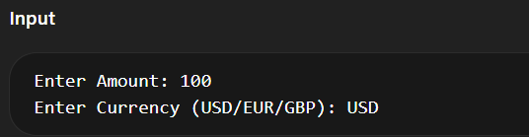

Sample Ouput:

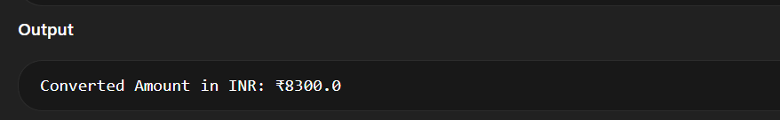

Sample Invalid Input

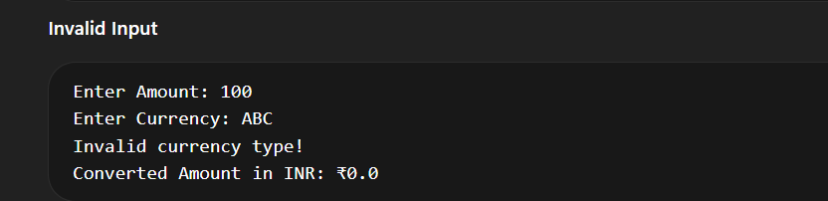

.

Future Enhancements

Real-Time Exchange Rate Integration

The Global Currency Converter can be significantly improved by integrating Real-Time Exchange Rate APIs, which would enable the system to fetch live currency values from reliable financial sources. Currently, the application relies on predefined exchange rates, which may not always reflect the latest market fluctuations. By incorporating API Integration, the system can provide accurate and up-to-date conversions, thereby increasing its reliability and practical usability in real-world financial scenarios.

Support for Multiple Currencies

Another important enhancement involves expanding the system to support Multiple International Currencies beyond USD, EUR, and GBP. By including currencies such as JPY, AUD, CAD, and AED, the application can cater to a broader range of global users and financial transactions. This improvement would enhance the scalability and flexibility of the system, making it more versatile and suitable for diverse international applications.

.

Graphical User Interface (GUI) Development

The current implementation utilizes a Console-Based User Interface, which, although functional, can be further enhanced by developing a Graphical User Interface (GUI) using technologies such as Java Swing or JavaFX. A GUI would provide an interactive and visually appealing environment, enabling users to perform currency conversions more intuitively. This enhancement would improve the user experience, accessibility, and ease of use, making the application suitable for non-technical users as well.

– Database Integration and History Tracking

Integrating a Database Management System (DBMS) such as MySQL or SQLite

would allow the system to store historical conversion data and maintain transaction records. This feature would enable users to review previous conversions and analyze currency trends over time. Additionally, data persistence would enhance the functional capabilities of the application and make it suitable for business and financial analysis.

Web and Mobile Application Development

To further extend its reach and usability, the Global Currency Converter can be transformed into a Web-Based or Mobile Application using modern technologies such as Spring Boot, HTML/CSS, JavaScript, or Android Development. This enhancement would allow users to access the system anytime and anywhere, increasing its availability and real-world applicability. Such advancements would make the project more aligned with current technological trends and industry standards.

Future Enhancements

Integration with real-time exchange rate APIs.

Addition of more international currencies.

Reverse conversion (INR to other currencies).

Development of a GUI using Java Swing or JavaFX.

Mobile or web-based implementation.

Database integration for storing historical rates.

GANTT CHART

Planning and Project Initiation

The Gantt Chart serves as a vital project management tool for the Global Currency Converter, enabling effective planning and organization of all development activities. The project begins with the Project Initiation and Requirement Analysis phases, where the project objectives, system scope, and user requirements are clearly defined. This initial stage establishes a strong foundation for subsequent tasks and ensures that the development process proceeds in a structured and systematic manner.

System Design and Development

Following the planning stage, the System Design and Development phases are scheduled within the Gantt Chart. During this period, the software architecture is designed using Object-Oriented Programming (OOP) principles, and the Utility Class such as ConverterEngine is created. The implementation of Static Variables, Static Methods, and the Conversion Logic takes place in this stage. Proper allocation of time to these tasks ensures efficient resource utilization and smooth progress of the project.

Testing and Documentation

The next phase highlighted in the Gantt Chart involves Testing, Debugging, and Documentation. During System Testing, the application is executed with various input scenarios to verify the accuracy and reliability of the currency conversion process. Simultaneously, comprehensive project documentation is prepared, including sections such as Abstract, Introduction, Methodology, and Implementation. This phase ensures that the system is both technically sound and academically well-presented.

Final Review and Submission

The final stage of the Gantt Chart focuses on Project Evaluation, Final Review, and Submission. During this period, the completed system is assessed to ensure that it meets all academic requirements and functional objectives. Any necessary refinements are made before the final submission and viva presentation. This structured timeline helps in effective time management, prevents last-minute delays, and ensures the successful completion of the project within the specified schedule.

Task | Duration | Week
Planning & Requirement Analysis | 2 Days | Week 1
System Design | 2 Days | Week 1
Coding | 4 Days | Week 1
Testing | 2 Days | Week 2
Documentation | 2 Days | Week 2
Final Submission | 4 Day | Week 2
Adding References |  |  | ✓

CONCLUSION

Project Overview

The Global Currency Converter project successfully demonstrates the practical implementation of Object-Oriented Programming (OOP) concepts using the Java Programming Language. The application provides a simple, efficient, and reliable solution for converting major international currencies such as USD, EUR, and GBP into Indian Rupees (INR). By utilizing Static Variables and Static Methods, the system ensures centralized management of exchange rates and promotes efficient memory usage, eliminating the need for unnecessary object instantiation

Achievement of Objectives

The project effectively achieves its primary objectives, including the development of a user-friendly system capable of performing accurate currency conversions. Through the implementation of a Utility Class named ConverterEngine, the system maintains a well-structured and modular architecture, enhancing code reusability, maintainability, and readability. The inclusion of input validation and error handling further improves the reliability and robustness of the application, ensuring consistent and dependable performance.

The Global Currency Converter project successfully demonstrates the practical implementation of Object-Oriented Programming concepts in Java. By utilizing static variables and methods, the system ensures efficient memory usage and centralized management of exchange rates. The application provides accurate and quick currency conversions, making it a useful tool for educational and practical purposes. The project also lays the foundation for future enhancements such as real-time data integration and graphical interfa

REFERENCE

Book

[1] H. Schildt, Java: The Complete Reference, 11th ed. New York: McGraw-Hill, 2018.

🌐 Website

[2] Oracle, "Java Documentation," Oracle. [Online]. Available: https://docs.oracle.com

📄 Journal Article

[3] A. Sharma and R. Gupta, "Machine Learning Techniques," International Journal of AI, vol. 5, no. 2, pp. 45-50, 2020.

📑 Conference Paper

[4] S. Kumar, "AI in Education," in Proc. IEEE Conference on AI, 2021, pp. 120-125.

